**MODUL 1 – INTRODUCTION TO DATABASE**

Topic : Introduction to Database

Objective : Students can identifies data and database system in real world

Time : 4 sessions

Method : Individual and discussion

Submission : **File upload to** **E-learning in pdf format. File name: P1-<your Nim>.pdf**

**Nim :3312411099**

**Name :Ardhitya Danur Siswondo**

**Class :IF MALAM D**

**Date :26/2/2025**

**Task 1:**

The following images is an example of status posting on Facebook.

|  |  |
| --- | --- |
|  |  |

Figure 1 Facebook posting

Following table is relational Table status. Please fill data in Table 1,2,3, and 4 **based on Figure 1.**

Table 1 Table status

|  |  |  |  |  |  |
| --- | --- | --- | --- | --- | --- |
| Id status | Creator | Date | Place | Status | Link |
| 1 | Budi Rahardjo | August 18 at 6:59am | Bandung | Kewarganegaraan 1.0: "Maka kalau sekarang kita masih meributkan tentang kewarganegaraan maka sebetulnya kita masih berada pada globalisasi 1.0. Sudah ketinggalan jaman." | Rahard.wordpress.com |

Table 2 Table Comments

| Id_Status | Id_Comment | Comment | Commentator | Date | Time |
| --- | --- | --- | --- | --- | --- |
| 1 | 1 | yaaay, saya sudah di 3.0 dong prof!! | Syahrul pribadi | August 18 | 7:17am |
| 1 | 2 | Karena perekonomian kita masih versi BETA, saya kira wajar jika proteksi dilakukan dengan kewarganegaraan versi RC | Pramudya Yanuanto | August 18 | 8:15am |
| 1 | 3 | Setuju pak. Soal UU kewarganegaraan ini memang framefwork turunan dari era Cold War dan memang harus dikaji ulang, karena negara-negara yang mengadopsi dwi kewarganegaraan terbukti banyak untungnya, terutama dari sisi ekonomi seperti India, Inggris, dsb. | Imam Fattah | August 18 | 7:39am |
| 1 | 4 | Kalo memang WNA boleh jadi pejabat public. Yg perlu dimasukin expratiate adalah hakim tipikor, jaksa ama polisi. | Pulung Bimasakti Ulung | August 18 | 9:02am |

please continue filling the table comments

Table 3 reply_comment

| Id Status | Id Comment | Id_reply_comment | Comment | Commentator | Date | Time |
| --- | --- | --- | --- | --- | --- | --- |
| 1 | 2 | 1 | Indonesia Tanah air masih versi beta | Wikan Danar Sunindyo | August 18 | 8:14am |
| 1 | 2 | 2 | Nah tu paham … hihihi | Pramudya Yanuanto | August 18 | 8:15am |
| 1 | 4 | 1 | Mungkin juga bagus, supaya gak punya hubungan keluarga (kkn) sama terdakwa ya. | Budi Rahardjo | August 18 | 9:12am |

please continue filling the table reply_comments

Table 4 Table User

|  |  |  |  |  |  |
| --- | --- | --- | --- | --- | --- |
| Email | password | User_name | Profile_picture | Join_Date | Address |
| budirahardjo@gmail.com | Budi1234 | Budi Rahardjo | Budi.jpg | 20 Jan 2014 | Bandung |
| syahrulpribadi@gmail.com | Syahrul1234 | Syahrul Pribadi | Syahrul.jpg | 12 Feb 2014 | Jakarta |
| pramudyayanuanto@gmail.com | Pramudya1234 | Pramudya Yanuanto | Pramudya.jpg | 13 Mar 2014 | Semarang |
| Imanfattah@gmail.com | Iman1234 | Iman Fattah | Iman.jpg | 24 May 2014 | Demak |
| pulungbimasaktiulung@gmail.com | Pulung1234 | Pulung Bimasakti Ulung | Pulung.jpg | 21 Jun 2014 | Medan |
| wikandanarsunindyo@gmail.com | Wikan1234 | Wikan Danar Sunindyo | Wikan.jpg | 22 Dec 2014 | Solo |

please continue fill data in table user (use dummy data except the user name)

**Task 2**

The following is example of flight search on ticketing website

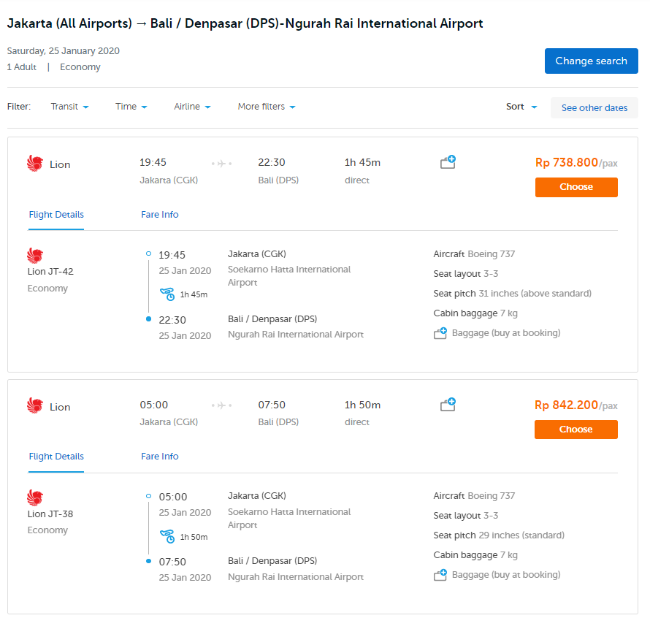

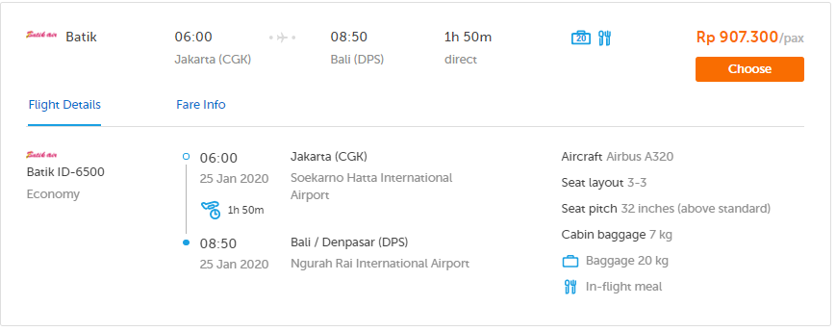

Figure 2 Ticketing Website

1. Convert data that you see in Figure 2 into two Tables, Table Flight and Flight Details
2. Define the Attribute and data based on the Figure 2

Table Flight

|  |  |  |  |  |
| --- | --- | --- | --- | --- |
| Makapai | Waktu Berangkat | Waktu Tiba | Durasi | Harga |
| Lion Air | 19:45 | 22:30 | 1h 45m | Rp 738.800 |
| Lion Air | 05:00 | 07:50 | 1h 50m | Rp 842.200 |
| Batik Air | 06:00 | 08:50 | 1h 50m | Rp 967.300 |

Table Flight Details

|  |  |  |  |  |
| --- | --- | --- | --- | --- |
| Maskapai | Kelas | Bandara Keberangkatan | Tipe  Pesawat | Bagasi |
| Lion Air | Ekonomi | Depansar(DPS) | Boeing 737 | 7 kg |
| Lion Air | Ekonomi | Denpasar(DPS) | Boeing 737 | 7 kg |
| Batik Air | Ekonomi | Depansar(DPS) | Airbus A320 | 20 kg |

**Task 3**

Do the following task:

1. Choose another example of software that using database system in real world.
2. Explain the software / application main features
3. Capture main feature and identifies the relation or table that might be use in that feature as we do in Task 1 and Task 2
4. Identifies at least 3 table
5. Write on the following page
6. The software / feature that chosen **must be different for each student** in a class

1.choose another example of software that using database system in real world.

Saya memilih mengidentifikasi Blibli – Aplikasi e-commerce untuk belanja online.

Blibli adalah salah satu platform e-commerce terbesar di Indonesia yang menyediakan berbagai produk mulai dari elektronik, fashion, kebutuhan rumah tangga, hingga tiket perjalanan. Aplikasi ini menggunakan sistem database untuk menyimpan dan mengelola data pengguna, produk, transaksi, dan lainnya.

2.Explain the software / application main features

Fitur-Fitur utama yang ada di aplikasi blibli:

1. **Pencarian dan katalog Produk**: Pengguna dapat mencari produk ke berdasarkan kategori, merek, atau harga.
2. **Keranjang Belanja dan Checkout**: Pengguna bisa menambahkan produk ke keranjang dan melakukan pembayaran dengan berbagai metode.
3. **Tracking Pesanan**: Pembeli dapat melacak status pesanan mulai dari pembayaran hingga penggiriman.
4. **Ulasan dan Rating Produk**: Pengguna bisa memberikan review dan rating terhadap produk yang dibeli.
5. **Promosi dan Cashback**: Tersedia berbagai promo, dan cashback untuk menarik pelanggan.

3. Capture main feature and identifies the relation or table that might be use in that feature as we do in Task 1 and Task 2

|  |
| --- |
|  |

Identifies Tabel Product

|  |  |  |  |  |  |  |  |
| --- | --- | --- | --- | --- | --- | --- | --- |
| ID Produk | Nama Produk | Kategori | Harga | Diskon | Terjual | Rating | Gambar Produk |
| 1 | Zojirushi NS-TSQ10 XJ Rice Cooker Digital Fuzzy Logic - Stainless [1 Liter] | elektronik | Rp 4.312.000 | 14% | 31 | Bintang 5 | Rice cooker  Digital Fuzzy Logic - Stainless [1 Liter] |
| 2 | STARLEAD Kasur Kesehatan - Firm Tanpa Lapisan Kapas-Orthopedic Support | Furniture | Rp 1.169.100 | 10% | 69 | Bintang 5 | Starlead  Kasur Kesehatan |
| 3 | Merries Pants Good Skin M 34 Popok Bayi [Carton Isi 4 Pack] | Kebutuhan Pokok | Rp 268.000 | 24% | 6,8 rb | Bintang 4,9 | Merries Pants  Good Skin M 34  Popok Bayi |
| 4 | Zojirushi SM-RB75E Vacuum Mug Tumbler Minum - [750 mL] | Tabung Minum | Rp 623.000 | 30% | 195 | Bintang 5 | Tumbler  Zojirushi SM-RB75E Vacuum Mug |
| 5 | Buttonscarves Everyday Scarf - Black | Hijab | Rp  245.000 | - | 136 | Bintang 5 | Hijab  Buttonscarves Everyday Scarf - Black |

* **Kegunaan**: Menyimpan informasi detail mengenai produk yang dijual di blibli

|  |
| --- |
|  |

Identifies Tabel Penjual (SELLER)

Atribut:

|  |  |  |  |  |  |
| --- | --- | --- | --- | --- | --- |
| ID penjual | Nama Toko | Lokasi Toko | Rating Penjual | Status Online/Offline | Jam Operasional |
| S001 | STARLEAD FURNITURE Official Store | Kab. Tangerang | Bintang 4,9 | Online | 08:00-17:00 |

* **Kegunaan**:Menyimpan informasi terkait penjual, termasuk lokasi dan rating

|  |
| --- |
|  |

Identifies Tabel Transaksi (Transaction)

Atribut:

|  |  |  |  |  |  |  |
| --- | --- | --- | --- | --- | --- | --- |
| ID Transaksi | ID Pembeli | ID Produk | Total Harga | Metode Pembayaran | Metode Pengirim | Voucher/Potongan harga |
| T5001 | C12345 | P1001 | Rp 1.179.100 | Bank BCA | Cargo | Rp 129.900 |

* **Kegunaan**:Checkout data pembelian, termasuk metode pembayaran, status pengiriman, dan penggunaan voucher.